**REAL TIME RESEARCH PROJECT**

On

**CINEVERSE**

*Submitted in the full fillment of the requirement for the award of the degree of*

**BACHELOR OF TECHNOLOGY**

In

**COMPUTER SCIENCE AND ENGINEERING**

**(ARTIFICIAL INTELLIGENCE AND MACHINE LEARNING)**

**By P. NANDINI 22D21A6626**

**P. PREETHI 22D21A6627**



**Department of Computer Science and Engineering (AI&ML)**

SRIDEVI WOMEN’S ENGINEERING COLLEGE

(Approved by AICTE and affiliated to JNTUH, An UGC Autonomous

Institution, Accredited by NBA &NAAC with A++ Grade

An ISO 9001:2015 certified Institution)

**V. N. PALLY(Y), Gandipet(M), Hyderabad-75**

**2023-2024**

**Department of computer science and engineering (AI&ML)**

SRIDEVI WOMEN’S ENGINEERING COLLEGE

(Approved by AICTE and affiliated to JNTUH, An UGC Autonomous

Institution, Accredited by NBA &NAAC with A++ Grade

An ISO 9001:2015 certified Institution)

**V. N. PALLY(Y), Gandipet(M), Hyderabad-75**

**2023-2024**



**CERTIFICATE**

This is to certify that the Technical Seminar Report entitled “CINEVERSE” is being submitted by Ms.P.NANDINI (H.T.No.22D21A6626) and Ms.P.PREETHI (H.T.No.22D21A6627) in partial fulfilment for the award of “Degree of Bachelor of Technology in computer science and engineering (Artificial Intelligence and Machine Learning)” is a record of bonafide work carried out by them.

**CO-ORDINATOR HEAD OF THE DEPARTMENT**

**Dr. D. Madhavi Dr. A . Ravi Kumar**

**(Assistant Professor) (Professor & HOD)**

INDEX

S.NO TITLE PAGE NO

1. Abstract 2

2. System Requirement Specification 3

3. Functionality of application 4

4. Sample Code 5

5. Screenshots 13

6. Conclusion 26

7. Future Enhancement 27

ABSTRACT

Welcome to CINEVERSE, your ultimate destination for discovering the movies and TV shows! Our platform offers a comprehensive information featuring movie titles, cast and crew details, streaming partners, and trailers. Easily navigate through our categorized sections for Languages, International, Indian, Chinese, and Korean dramas, steaming platforms each showcasing the latest releases and popular hits. With other websites finding where to watch your favourite movies and shows has never been easier. Click on any streaming partner's name, and you'll be directed to their platform to start watching instantly. Want to check out a trailer first? Just click on the trailer link, and it will play directly on YouTube. Our user-friendly interface allows you to select by language or streaming partner, ensuring you find exactly what you're looking for. Whether you're in the mood for an international and Indian blockbuster or a binge-worthy Korean drama, we've got you covered with detailed information about seasons, episodes, and streaming platforms availability. Explore CINEVERSE today and dive into a world of endless entertainment possibilities!

**SYSTEM REQUIREMENT SPECIFICATION**

**HARDWARE REQUIREMENTS:** Minimum hardware requirements are very dependent on the particular software being developed by a given though HTML, CSS. Applications that are need to store large objects/modules in memory will require more RAM, whereas application that need to perform numerous tasks more quickly will require a faster processor.

* System : Windows 11
* Processor : AMD Ryzen 3
* Hard Disk : 930 GB.

**SOFTWARE REQUIREMENTS**: The functional requirements or the overall description documents include the product perspective and features, operating system and operating environment, graphics requirements, design constraints and user documentation.

The appropriation of requirements and implementation constraints gives the general overview of the project in regards to what the areas of strength and deficit are and how to tackle them.

* Operating System : Windows 11
* Coding Language : HTML, CSS

**FUNCTIONALITY OF APPLICATOINS**

Functionality includes features such as speed, ease of use and reliability. A well-functioning website can increase user satisfaction and retention and even lead to positive marketing. However, if a website has poor functionality, customers may quickly become frustrated and abandon it.

**User Interaction:** Users search for movies using keywords, categories, or streaming partners. Search requests are processed to fetch relevant movie details from the database. Results are displayed, allowing users to view details, watch trailers, or stream movies.

**Database management**: A centralized movie database stores all movie details. Regular updates ensure the latest information is available. Data validation mechanisms prevent errors and ensure accuracy.

**User interface**: User-friendly search bar and filters for easy navigation. Display includes movie titles, thumbnails, cast and crew information, streaming partner links, and trailer links. Separate sections for International, Indian, Chinese, and Korean dramas. Each section provides detailed information about available seasons and episodes.

**Streaming Partner Integration**: Each movie’s details page includes direct links to streaming partners. Clicking a link redirects the user to the partner’s platform for seamless streaming. Embedded YouTube links for trailers Users can watch trailers without leaving the website, enhancing the browsing experience.

**Administrative management**: Administrators input movie details, ensuring accuracy and completeness. Regular checks and updates are performed to maintain data integrity. Continuous monitoring of streaming partner availability and trailer links. Updates are applied promptly to reflect changes in streaming rights and new releases.

SAMPLE CODE

<!DOCTYPE html>

<html lang="en">

<head>

<meta charset="UTF-8">

<meta name="viewport" content="width=device-width, initial-scale=1.0">

<title>CINEVERSE</title>

<style>

/* Style the navigation bar */

.navbar {

overflow: hidden;

background-color: #333;

}

/* Style the links inside the navigation bar */

.navbar a {

float: left;

display: block;

color: white;

text-align: center;

padding: 14px 20px;

text-decoration: none;

}

/* Change color on hover */

.navbar a:hover {

background-color: #ddd;

color: black;

}

/* Style the dropdown button */

.dropdown {

float: left;

overflow: hidden;

}

/* Style the dropdown button itself */

.dropdown .dropbtn {

font-size: 16px;

border: none;

outline: none;

color: white;

padding: 14px 20px;

background-color: inherit;

font-family: inherit;

margin: 0;

}

/* Style the dropdown content (hidden by default) */

.dropdown-content {

display: none;

position: absolute;

background-color: #f9f9f9;

min-width: 160px;

box-shadow: 0px 8px 16px 0px rgba(0,0,0,0.2);

z-index: 1;

}

/* Style links inside the dropdown */

.dropdown-content a {

float: none;

color: black;

padding: 12px 16px;

text-decoration: none;

display: block;

text-align: left;

}

/* Add a grey background color to dropdown links on hover */

.dropdown-content a:hover {

background-color: #ddd;

}

/* Show the dropdown menu on hover */

.dropdown:hover .dropdown-content {

display: block;

}

h1{

font-size: 36px;

font-weight: bold;

color: #333;

margin-bottom: 20px;

text-align: center;

text-transform: uppercase;

}

</style>

</head>

<body>

<div class="navbar">

<a href="#">Home</a>

<div class="dropdown">

<button class="dropbtn">Language</button>

<div class="dropdown-content">

<a href="Telugu2.html">Telugu</a>

<a href="Hindi.html">Hindi</a>

<a href="English2.html">English</a>

<!-- Add more language options here if needed -->

</div>

</div>

<div class="dropdown">

<button class="dropbtn">Platform</button>

<div class="dropdown-content">

<a href="Netflix.html">NETFLIX</a>

<a href="Prime video.html">PRIMEVIDEO</a>

<a href="Disney+hotstar.html">DISNEY+HOTSTAR</a>

<a href="Zee5.html">ZEE5</a>

<a href="Jiocinema.html">JIOCINEMA</a>

<!-- Add more language options here if needed -->

</div>

</div>

<a href="About.html">About Us

<a href="Contact us.html">Get In Touch</a>

</a>

<form action="*/search"method="GET" Class="search-form">

<input type="text" name="query" placeholder="search...." class="search-input">

<button type="submit" class="search button">Search</button>

</form>

<style>

/* Style for the search bar */

.search-container {

float:right;

}

input[type=text] {

padding: 6px;

margin-top: 5px;

font-size: 17px;

border: none;

}

button {

padding: 6px 10px;

margin-top: 0px;

margin-right: 20px;

background: #ccc;

font-size: 17px;

border: 20px,25px;

cursor: pointer;

}

</style>

</div>

</body>

<h1>CINEVERSE</h1>

<title>Picture Blocks</title>

<style>

.picture-blocks {

display: grid;

grid-template-columns: repeat(auto-fill, minmax(300px, 1fr)); /* Adjust the minimum and maximum width of each block */

grid-gap: 10px; /* Adjust the gap between blocks */

}

.picture-blocks img {

width:100%; /* Ensure images take up the full width of their container */

height: 300px;; /* Maintain aspect ratio */

display: block;

}

</style>

<body>

<div class="picture-blocks">

<style>

/* Basic CSS for image and text layout */

.image-with-text {

text-align: center;

}

.image-with-text img {

max-width: 100%;

height: 500px;

display: block;

margin: 0 auto;

}

.image-with-text p {

margin-top: 10px;

}

</style>

</body>

<body>

<!-- Image with text -->

<div class="image-with-text">

<img src="https://m.mediaamazon.com/images/M/MV5BZDY5NWFjOTctNTQ0ZC00OGM5LWJkMmItN2RjNGZhMmEwMGMyXkEyXkFqcGdeQXVyMTUzNTgzNzM0._V1_.jpg" alt="Image"width="500" height="500">

<p>CREW</p>

<a href="https://www.netflix.com/in/title/81672746?source=35">Available in <b>NETFLIX</b></a>

<p>CAST:Tabu(actress)<br>Kareena Kapoor Khan(actress)<br>Kriti Sanon(actress)</p>

<a href="https://youtu.be/3uvfq4Cu8R8?si=v07Q3DtUICV2OITJ">Trailer</a>.

</div>

<style>

/* Basic CSS for image and text layout */

.image-with-text {

text-align: center;

}

.image-with-text img {

max-width: 100%;

height:500px;

display: block;

margin: 0 auto;

}

.image-with-text p {

margin-top: 10px;

}

</style>

</body>

</html>

SCREENSHOTS

* The below image shows the banner and navigation bar of the website.

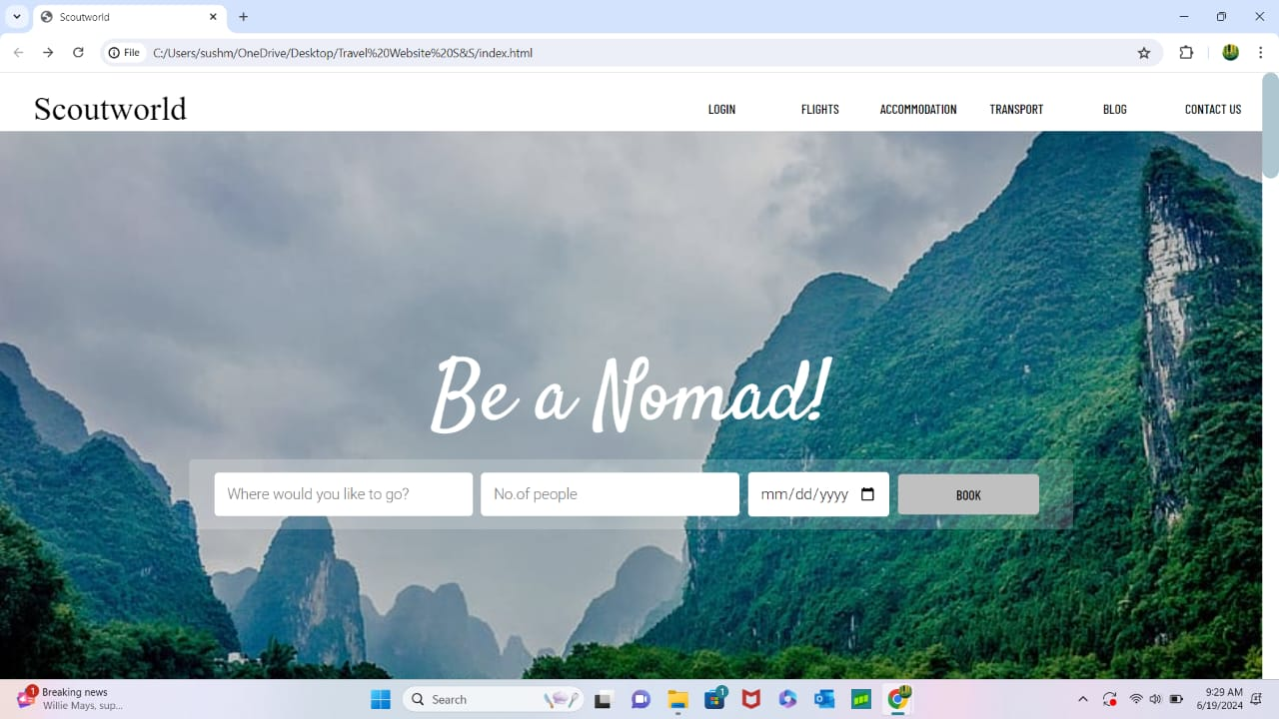

* The below image shows the login page of the website.
* The below image shows the flight details.

CONCLUSION

CINEVERSE stands out in the competitive landscape of movie streaming platforms, particularly when compared to sites like iBomma. While iBomma focuses primarily on providing access to Indian regional content, CINEVERSE offers a more diverse and comprehensive selection, including international, Indian, Chinese, and Korean dramas. This wide-ranging categorization ensures that users can easily find content from different regions and genres, catering to a broader audience. One of the key advantages of CINEVERE over iBomma is its seamless integration with multiple streaming partners. Users can effortlessly navigate to their preferred streaming service with a single click, providing a smooth and uninterrupted viewing experience. In contrast, iBomma often requires additional steps or redirects, which can disrupt the user experience. Furthermore, CINEVERSE enhances user engagement with its direct links to YouTube trailers, allowing users to preview movies without leaving the site. This feature, combined with detailed cast and crew information, offers a richer, more informative browsing experience compared to iBomma. Overall, CINEVERSE  not only matches but surpasses the functionalities of iBomma by offering a more user-friendly interface, diverse content library, and efficient integration with popular streaming platforms and YouTube. This makes Cineverse the go-to destination for a truly global movie and TV show streaming experience.

FUTURE ENHANCEMENT

**Release Dates Integration**: Upcoming movie release dates incorporate a dedicated section for upcoming movie release dates. This will allow users to stay informed about the latest releases and plan their viewing schedules accordingly. Streaming platform release dates provide information on when movies or dramas will be available on specific streaming platforms. Users can track their favorite shows and movies and know exactly when they can start streaming.

**Genre Segregation**: Introduce advanced filtering options to segregate movies and shows by genres such as Action, Comedy, Drama, Thriller, Romance, Sci-Fi, Horror, and more. This will help users find content that matches their preferences quickly and easily.

**Personalized User Experience** : Create personalized user profiles where users can save their favorite movies, shows, and genres. This will help in offering tailored recommendations based on their viewing history and preferences.

Watchlists: Enable users to create and manage watchlists for movies and shows they plan to watch. Notifications can be sent when a movie or show on their watchlist is released or becomes available on a streaming platform.

User Reviews and Ratings: Add a section where users can leave reviews and ratings for movies and shows. This will help other users make informed decisions based on communityfeedback**.**